*https://www.intel.com/content/dam/support/us/en/documents/edison/sb/edison-arduino-hardware-guide.pdf*

*https://software.intel.com/en-us/xdk/docs/lp-xdk-iot*

***https://software.intel.com/en-us/iot/hardware/edison***

***http://www.instructables.com/id/Absolute-Beginners-Guide-To-The-Intel-Edison/***

***https://software.intel.com/en-us/node/628224***

- - - -Setup- - - -

https://software.intel.com/en-us/intel-xdk

https://software.intel.com/en-us/get-started-edison-windows-step2

https://software.intel.com/en-us/installing-drivers-for-intel-edison-board-with-windows

https://www.arduino.cc/en/Guide/IntelEdison

**..........References........**

https://www.hackster.io/pooja_baraskar/projects

...........Using Arduino..............

https://software.intel.com/en-us/get-started-arduino-blink

https://www.intel.in/content/www/in/en/support/boards-and-kits/000006330.html

https://software.intel.com/en-us/articles/send-sms-messages-using-twilio-and-arduino-on-intel-edison

http://www.instructables.com/id/Intel-IoT-Edison**-Sonar-**Theremin/

http://howtomechatronics.com/tutorials/arduino/**ultrasonic-sensor-hc-**sr04/

http://www.instructables.com/id/Intel-IoT-Edison-sonar-rangefinder-**distance-meter**/

http://bigdinotech.com/tutorials/galileo-tutorials/**using-ultrasonic-ping-sensor-with-intel-galileo-and**-edison/

http://www.instructables.com/id/Intel-Edison-Distance-Bug-HC-SR04/

http://www.instructables.com/id/Send-SMS-from-Arduino-over-the-Internet-using-ENC2/

https://diyhacking.com/esp8266-tutorial/

**http://www.instructables.com/id/Intel-Edison-Simple-Distance-Sensor-with-Grove-LED/**

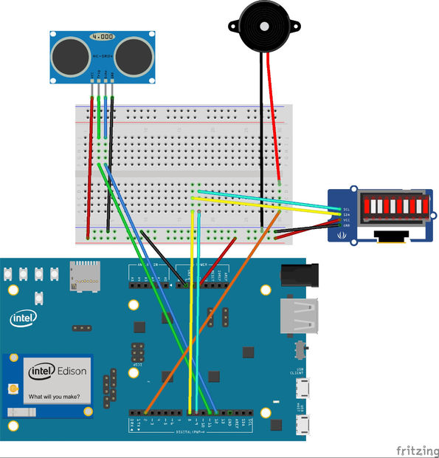

https://www.intel.in/content/www/in/en/support/boards-and-kits/000006330.html

https://www.intel.in/content/www/in/en/support/boards-and-kits/000006330.html

?

?  
?  
?  
?

http://www.instructables.com/id/Sending-SMS-and-Email-from-your-IoT-device/

?

?  
?  
?

01/10/2017

https://circuitdigest.com/microcontroller-projects/sending-sms-using-esp8266

https://www.intel.in/content/www/in/en/support/boards-and-kits/000006164.html

AWS- - -(amazon web services)

https://www.hackster.io/iot-warriors/scalable-intelligent-air-quality-monitoring-and-response-b72732?ref=part&ref_id=8232&offset=6

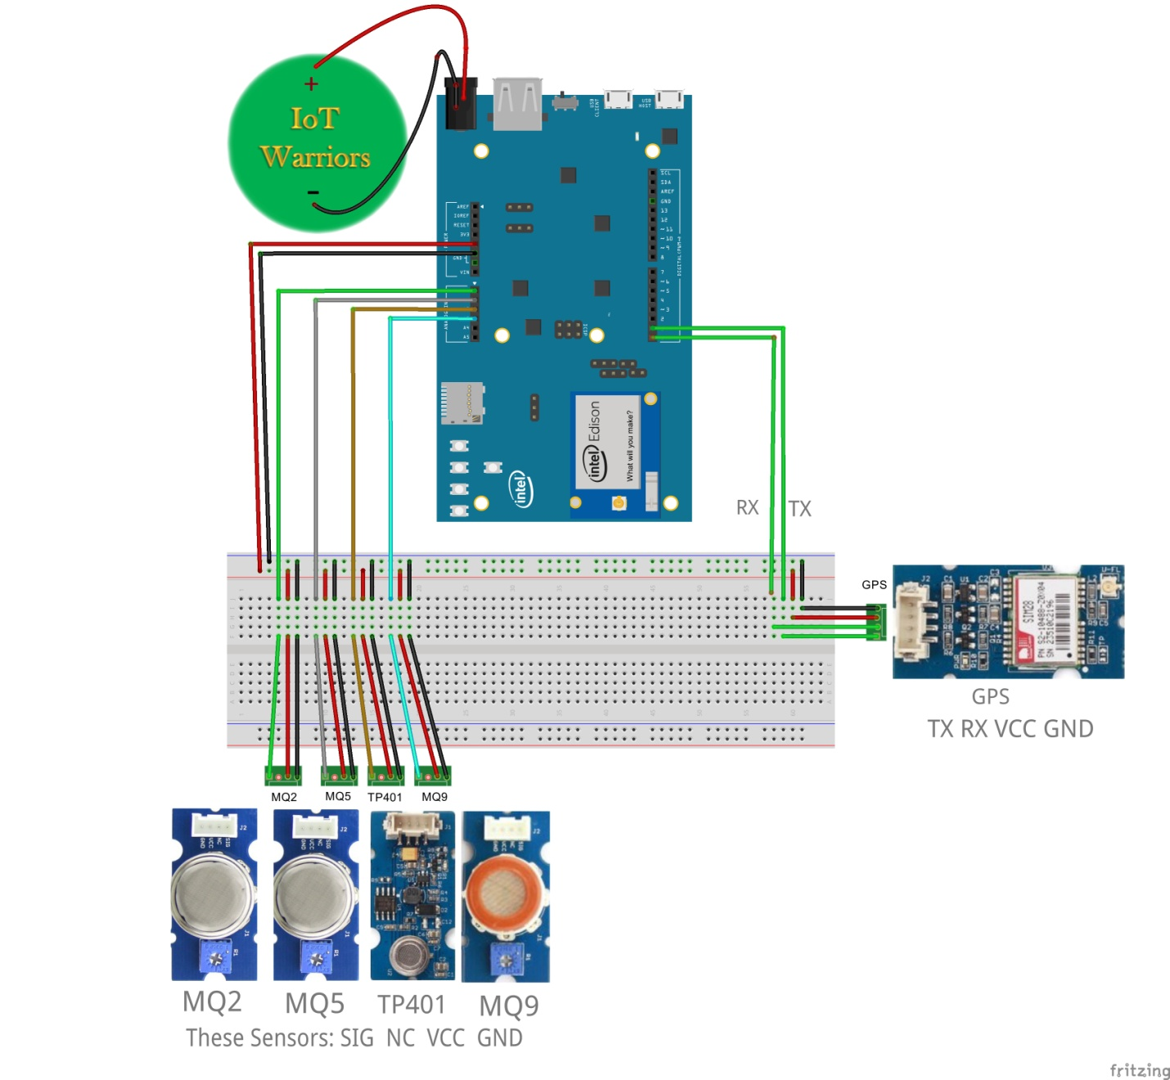

***How to connecct edison to wifi by arduino code* * *

https://learn.sparkfun.com/tutorials/edison-getting-started-guide

using xdk IOT edition/node.jss

https://dzone.com/articles/burglar-alarm-with-sending-sms-and-email-from-your

https://github.com/rwaldron/johnny-five/blob/master/docs/edison-io-arduino.md

**http://www.instructables.com/id/Sending-SMS-and-Email-from-your-IoT-device/**

https://www.hackster.io/pooja_baraskar/burglar-alarm-with-sending-sms-and-email-from-iot-device-9a9917

https://www.hackster.io/pooja_baraskar/smart-baby-monitor-ubidots-70583e

http://www.instructables.com/id/Sending-SMS-and-Email-from-your-IoT-device/

https://www.hackster.io/iot-warriors/scalable-intelligent-air-quality-monitoring-and-response-b72732?ref=part&ref_id=8232&offset=6

https://www.hackster.io/pooja_baraskar/let-s-make-a-smartwatch-30c649

https://www.hackster.io/pooja_baraskar/environment-monitor-with-aws-iot-a80a30

https://www.hackster.io/pooja_baraskar/let-s-make-a-smartwatch-with-aws-iot-661fed

https://github.com/gomobile/template-blank-cordova-project-lite

if you want it using GSM-Module

https://create.arduino.cc/projecthub/eani/diy-how-to-use-the-arduino-uno-to-send-an-email-sms-an-28ac4d

using other Modules

https://create.arduino.cc/projecthub/MatthewHallberg/intruder-alarm-with-text-message-notification-a38ae9

USINNG TEMMBO

https://temboo.com/arduino/others/send-sms

https://www.survivingwithandroid.com/2015/09/iot-**arduino**-push-message-android-2.html

USING twilio

https://create.arduino.cc/projecthub/MatthewHallberg/intruder-alarm-with-text-message-notification-a38ae9

extra using ESP8266

https://www.twilio.com/docs/guides/send-sms-and-mms-messages-esp8266-cpp#sign-into-or-sign-up-for-a-twilio-account

Extra - - - -(Using arduino GSM Shield)

http://www.instructables.com/id/Tweet-with-your-Intel-Edison/

https://www.hackster.io/pooja_baraskar/smart-baby-monitor-ubidots-70583e

https://www.hackster.io/pooja_baraskar/burglar-alarm-with-pir-motion-sensor-964c42

https://create.arduino.cc/projecthub/eani/diy-how-to-use-the-arduino-uno-to-send-an-email-sms-an-28ac4d

https://www.arduino.cc/en/Tutorial/GSMExamplesWebServer

https://www.arduino.cc/en/Tutorial/GSMExamplesSendSMS

https://www.arduino.cc/en/Tutorial/GSMExamplesReceiveSMS



"You cant tstudy books- - donnt want to start eating/learning end to end- - -byheart -- - ""best way to learn bleieve me is , ex. arduino/techs/etc,

..............by doing/serchings/edditing/contributing to opensources/projeccts........................

(make a impacct_ - - - - -))